Day 6 — Word Count

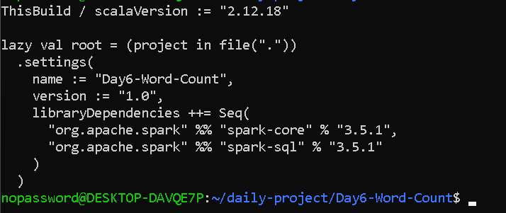

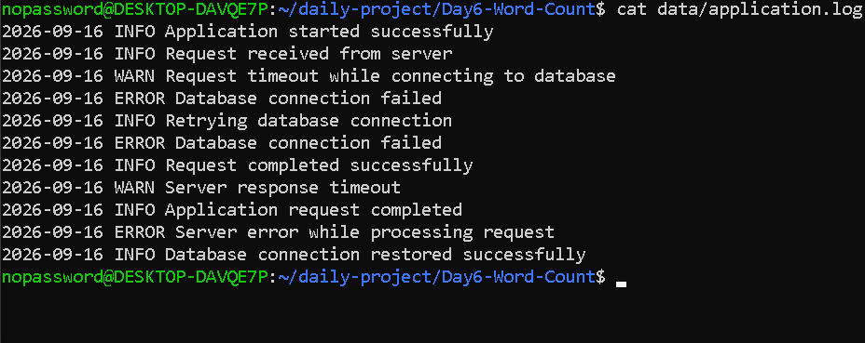

nopassword@DESKTOP-DAVQE7P:~/daily-project/Day6-Word-Count$ cat src/main/scala/WordCount.scala
import org.apache.spark.sql.SparkSession

object WordCount {

def main(args: Array[String]): Unit = {

val spark = SparkSession.builder()
.appName("Day6-WordCount")
.master("local[*]")
.getOrCreate()

val sc = spark.sparkContext

val lines = sc.textFile("data/application.log")

val wordCounts = lines
.flatMap { line =>
line
.toLowerCase
.replaceAll("[^a-z0-9]+", " ")
.split("\\s+")
.filter(_.nonEmpty)
}
.map(word => (word, 1))
.reduceByKey(_ + _)

println("=== Classic Word Count ===")

wordCounts
.sortByKey()
.collect()
.foreach(println)

println("\n=== Top 10 Most Frequent Words ===")

wordCounts
.sortBy { case (_, count) => -count }
.take(10)
.foreach(println)

spark.stop()
}
}

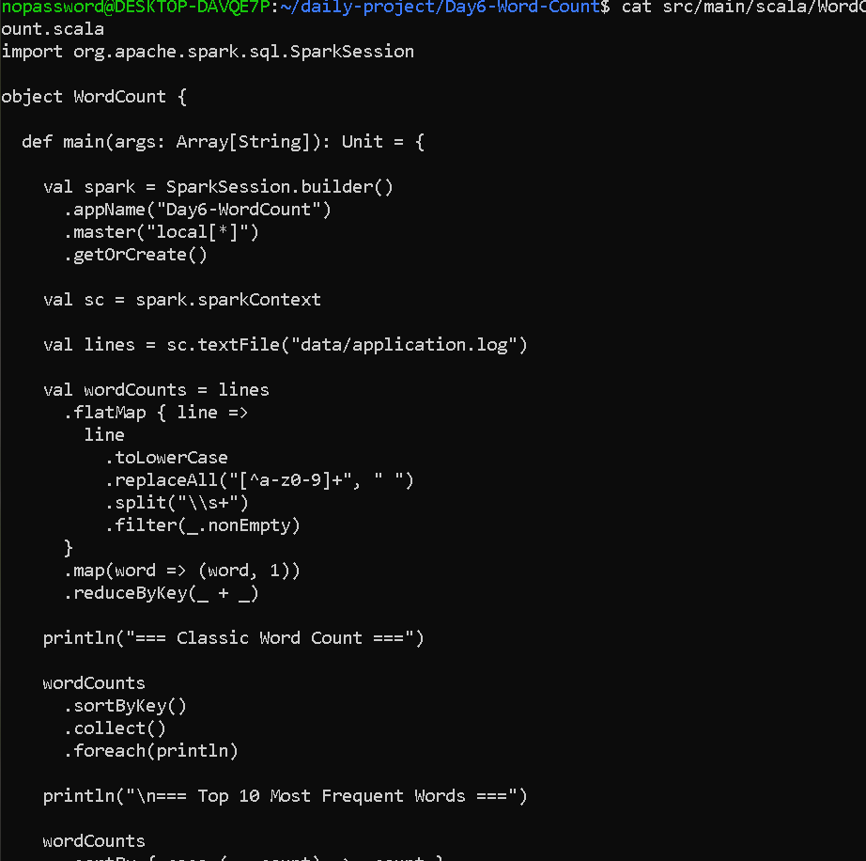

OUTPUT---

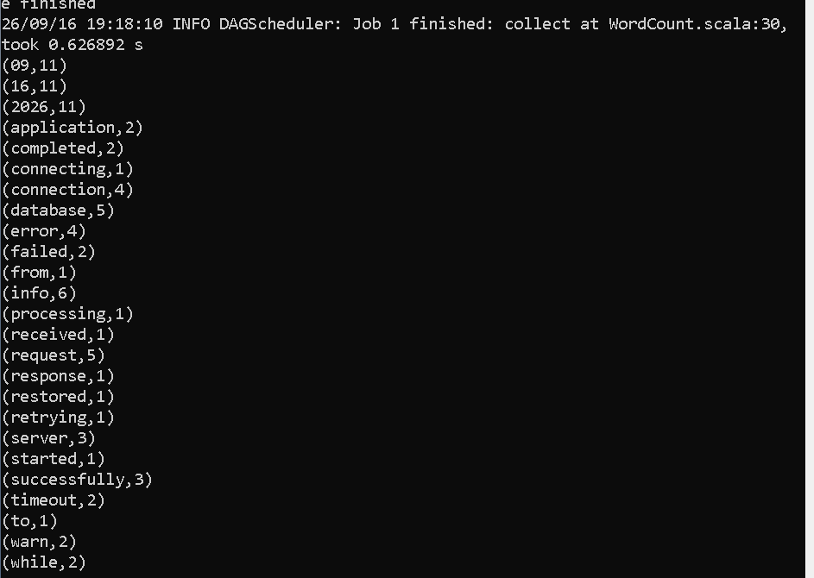

=== Top 10 Most Frequent Words ===
